Hotel Reservation Form
Courtyard by Marriott Suwon
ITS KOREA 2025 staying 26th May ~ 31st May 2025
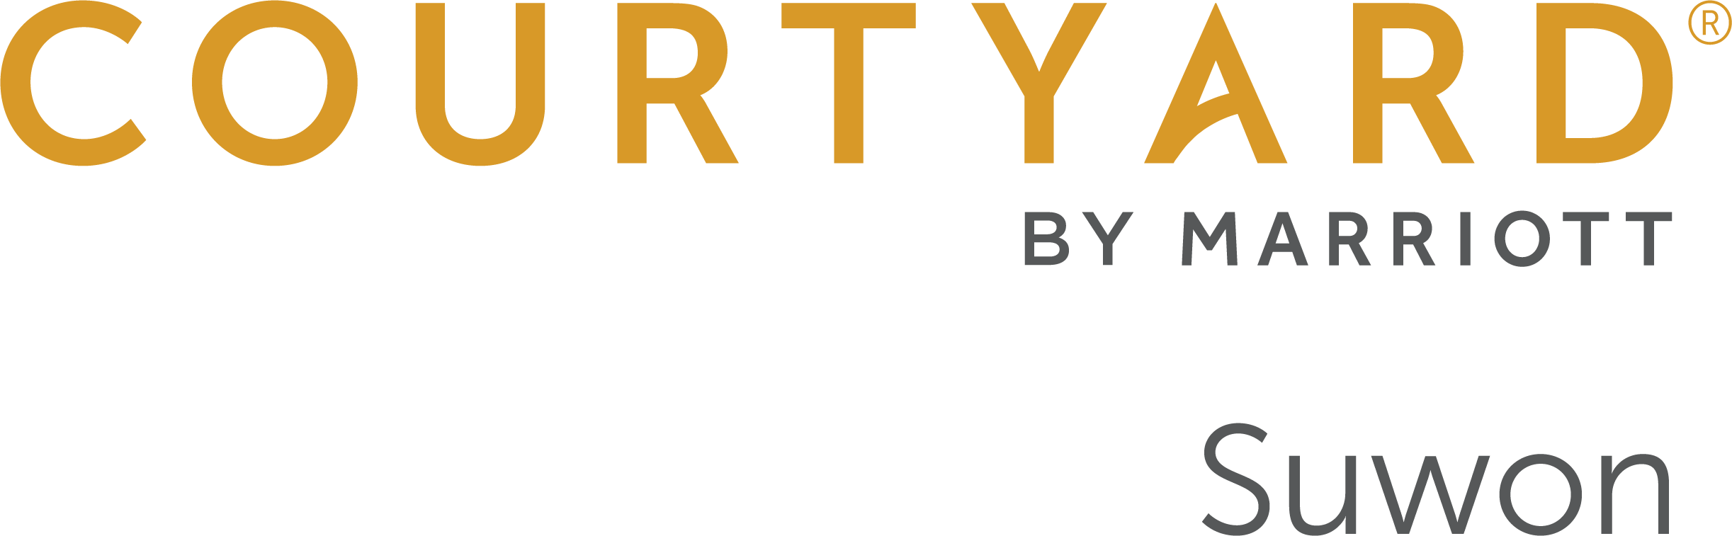

320, Gwanggyohosugongwon-ro, Yeongtong-gu, Suwon, 16514, South Korea
Phone: 82-31-267-6700 / Fax: 82-31-267-5601
For Reservation, Attention to Reservation manager
Please e-mail to cy.selcw.reservation@courtyard.com
Copy to Sarah.park@courtyard.com

Personal Information

Reservation can be made up until 30th April 2025
Mr. / Ms. | Last Name: | Middle Name: | First Name:
Company/Organization: |  | Bonvoy Membership Number:
Work Phone:
Country code Area code Number

E-mail:

Itinerary & Room Reservation
Arrival(MM/DD/YY):  Estimated Arrival Time:  (Check-in: 15:00) | Departure(MM/DD/YY):  (Check out: 12:00)
ROOM RATE
Premier Room (All - Non Smoking rooms)  Room Size : 28㎡  □ Premier King or Double (Room only) KRW 220,000  □ Premier King or Double (1breakfast) KRW 240,000  □ Premier King or Double (2breakfast) KRW 260,000  * Please mark x which you prefer.  * Additional Breakfast charge KRW 45,100 per person on site.  * All rates are Excluded 10% VAT.  General Benefits  * Complimentary use of the gym on 3rd floor  * Free WIFI access at the guest room | Deluxe King Room (All - Non Smoking rooms)  Room Size : 31㎡  □ Deluxe King (Room only) KRW 270,000  □ Deluxe King (1breakfast) KRW 290,000  □ Deluxe King (2breakfast) KRW 310,000  * Please mark x which you prefer.  * Additional Breakfast charge KRW 45,100 per person on site.  * All rates are Excluded 10% VAT.  General Benefits  * Complimentary use of the gym on 3rd floor  * Free WIFI access at the guest room
* Special request if necessary: | * Special request if necessary:

Please offer your credit card information to guarantee your reservation via E-sertifi link.
(*Link will be provided to insert your credit card information from reservation center via e-mail. Please fill it in the link to guarantee your reservation.)
Cancellation Policy | Cancel request after 30th Apr. 2025, 100% Cancellation Penalty will be charged for the whole stay reserved.
Agreed for providing personal information to hotel | □Yes □No
Signature:

Please complete this form and return it directly to hotel by e-mail.
Contact Person | Phone | Fax | Email
Reservation | 82-31-267-6700 | 82-31-267-5601 | cy.selcw.reservation@courtyard.com

